**Lab 2**

MOSFET Sizing and CS Amplifier

Part 1: Sizing Chart

Required Spec:

|  |  |
| --- | --- |
| **DC Gain** | -12 |
| **Supply** | 3v |
| **Current Consumption** | 200uA |

Analytic Calculations:

To get Large Output Swing: Assume

This concludes the initial Gain Calculation, We will use the obtained results on a sizing testbench to get the remaining required design parameters to meet the required Spec.

Testbench Schematic:

Using **W/L = 10u/2u** and **VDS = 1.5,**  The choice for Dimension does not really matter right now as we will use cross multiplication later to calculate the required sizing values for the amplifier.

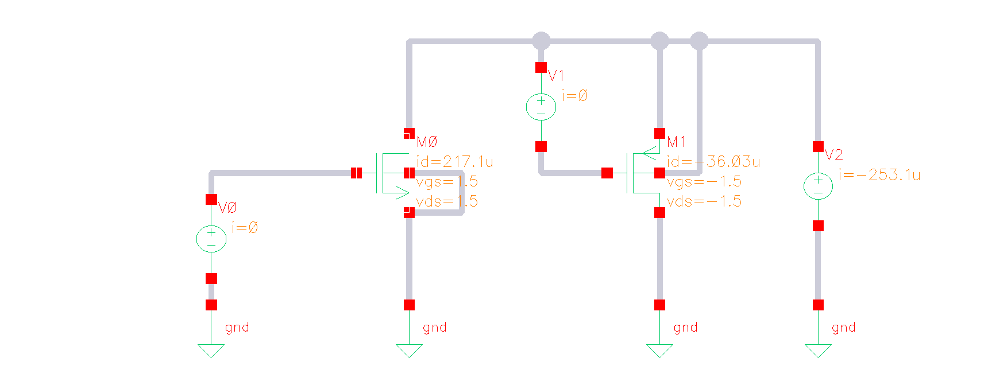

Figure 1 Sizing Testbench Schematic

Sweeping VGS from 0:10mV:(Vth + 0.4):

I ran a simple DC Op run once to determine the value of VTH

Figure 2 Value of Vth from simulation

V* and Vov Overlaid vs VGS:

Figure 3 Output Setup and Expressions for Vov and V*

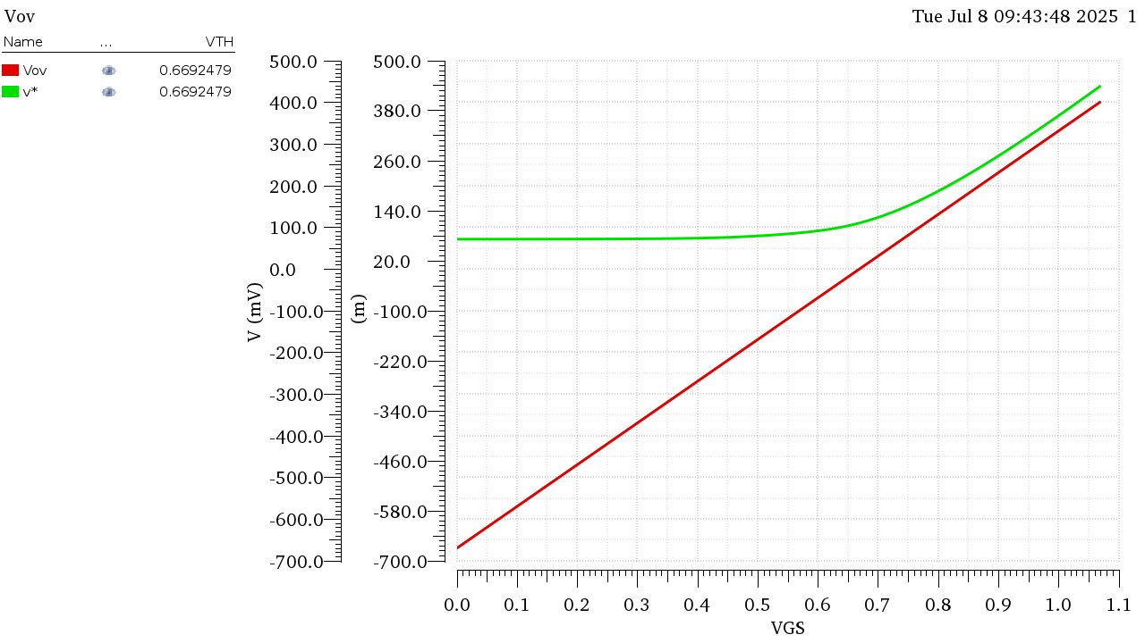

Figure 4 Vov and V* vs VGS NMOS

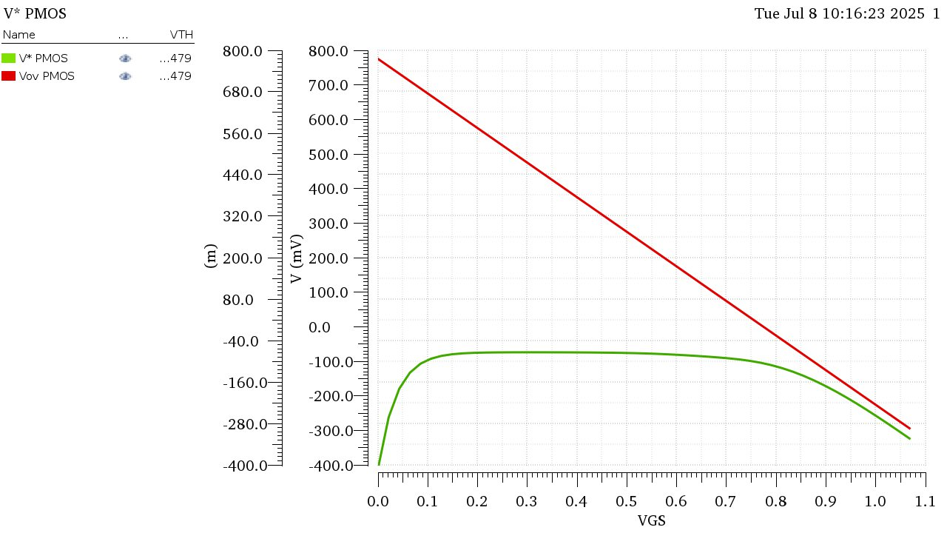

Figure 5 Vov and V* vs VGS PMOS

**Comment:** Vov and V* are relatively close in value to each other at the beginning of the Strong Inversion region meaning the square law is relatively valid in that region. But for Deep Strong inversion (Large Vov) or weak inversion, the behavior is quite far despite using a Long Channel Length.

Locating V*Q and VGSQ, Vovq:

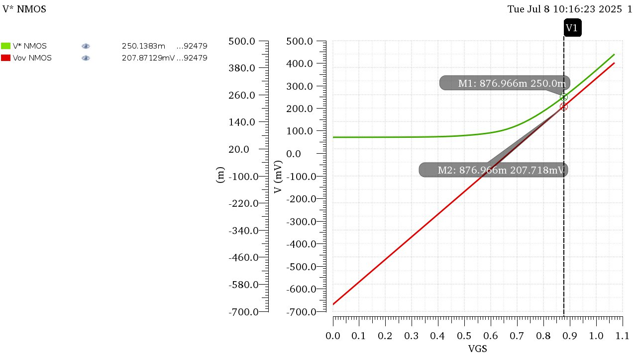

Figure 6 V*q, Vovq and Vgsq NMOS

Plotting ID, gm, gds vs VGS:

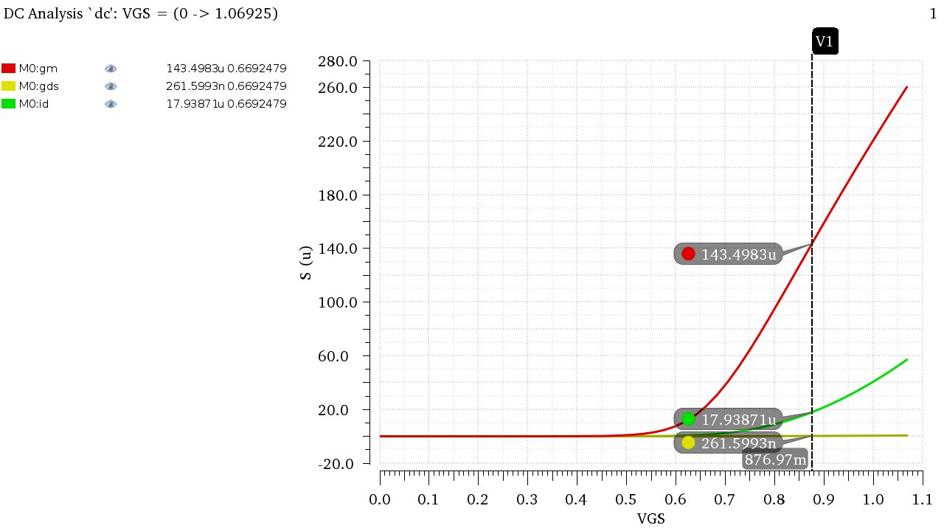

Figure 7 ID, gm, gds vs VGS and their corresponding values at Vgsq

|  |  |
| --- | --- |
| **IDx** | 17.94uA |
| **gmx** | 143.5uS |
| **gdsx** | 261.6nS |

Getting the Value of W:

These Values were Calculated at W=10um, to get the actual value of W for the design we can simply do cross multiplication since Id is directly proportional to W regardless square law is valid or no.

|  |  |
| --- | --- |
| 𝑾 | 𝑰𝑫 |
| 𝟏𝟎𝝁𝒎 | 𝐼𝐷𝑋 @𝑉𝑄∗ (from the chart) |
| **?** | 𝐼𝐷𝑄 = 200𝜇𝐴 (from the specs) |

W is greater than Wmax of the technology prompting us to use multipliers to achieve the required dimensions

Calculating the remaining Design parameters and verifying results analytically:

Using cross-multiplication we can get the values of gmQ and gdsQ as follows…

|  |  |  |
| --- | --- | --- |
| **W** | **gm** | **gds** |
| 𝟏𝟎𝝁𝒎 | gmx = 143.5uS | gdsx = 261.6nS |
|  | gmq | gdsq |

**Verifying Gain:**

The parameters are correct!

Final Parameter List:

|  |  |
| --- | --- |
| **W** | 111.48 um |
| **L** | 2 um |
| **gm** | 1.6 mS |
| **gds** | 2.916 uS |
| **ro** | 342.9 kΩ |
| **RD** | 7.5 KΩ |
| **Vgs** | 876.97 mV |

Part 2: CS Amplifier

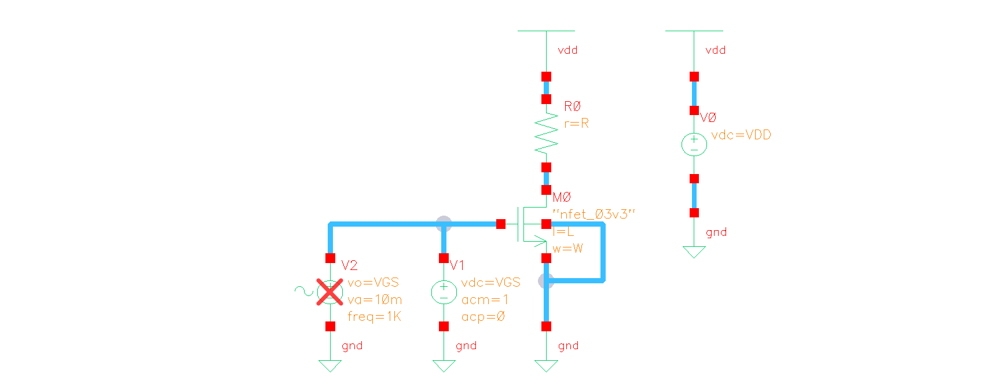

Figure 8 CS Amplifier Schematic Ready for DC, AC and Transient analyses

DC Operating Point Check:

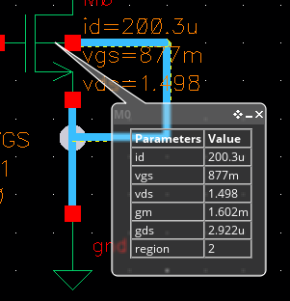

Figure 9 OP Point using Ballons

Comparing Analytic and Simulation Results for OP Point:

|  |  |  |
| --- | --- | --- |
| **Parameter** | **Simulation** | **Analytic** |
| **Vgs** | 877 mV | 876.96 mV |
| **Id** | 200.3 uA | 200 uA |
| **gm** | 1.602 mS | 1.6 mS |
| **gds** | 2.922 uS | 2.916 uS |
| **ro** | 342.23 KΩ | 342.935 KΩ |

The results are almost identical due to using a chart-based approach.

* Compare 𝑟𝑜 and 𝑅𝐷. Is the assumption of ignoring 𝑟𝑜 justified in this case? Do you expect the error to remain the same if we use min 𝐿?

Therefore, It is safe to neglect ro in this case.

In case of using min L, Since ro and L are directly proportional, ro will massively decrease by decreasing L to a point where it is no longer valid to neglect it as it will have a value comparable with Rd.

* Calculate the intrinsic gain of the transistor.
* Calculate the amplifier gain analytically. What is the relation (≪, <, ≈, >, ≫) between the amplifier gain and the intrinsic gain?

Amplifier Gain is much less than () Intrinsic Gain.

AC Analysis: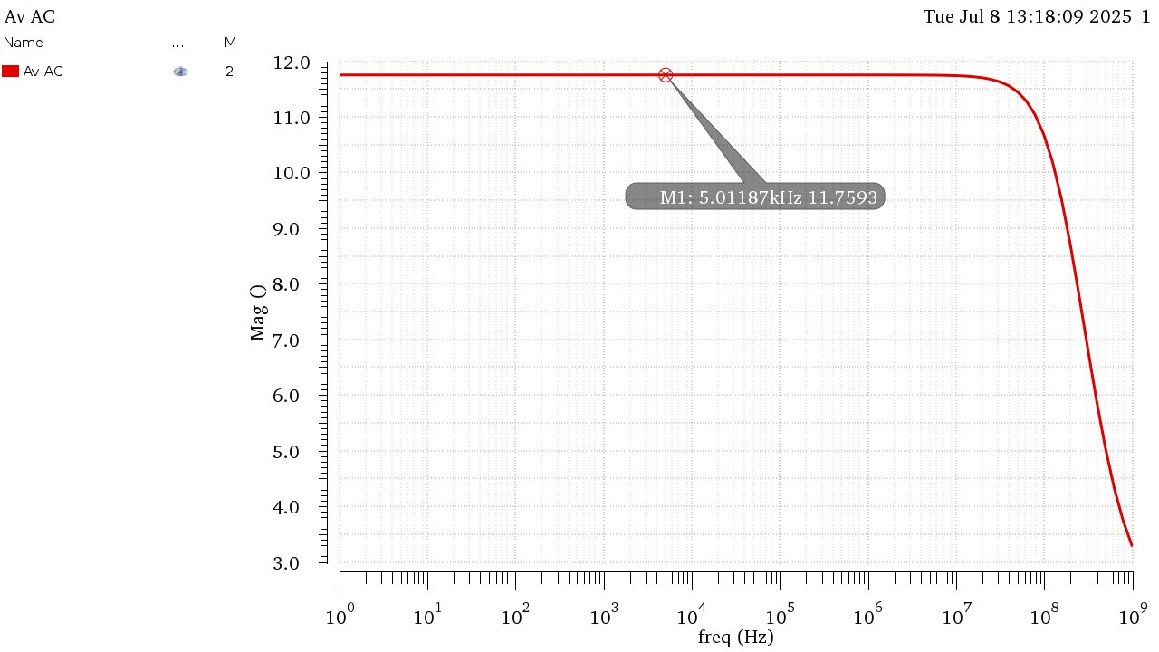

Figure 10 DC Gain from AC Analysis

Gain = 11.7593, Agrees with Analytical Results and approximately equal to the required spec.

VOUT vs VIN:

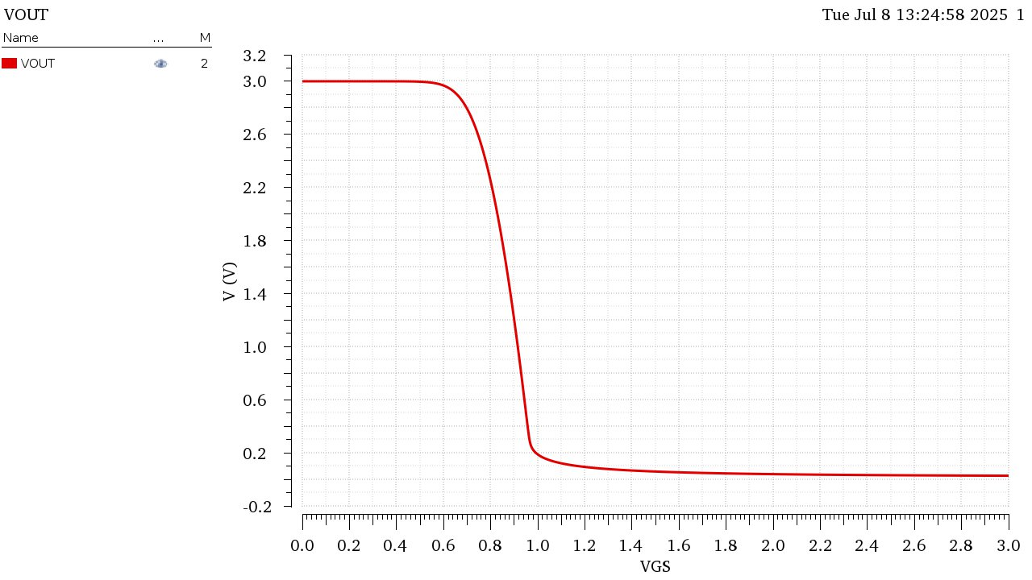

Figure 11 VOUT vs VIN graph

The relation between VIN and VOUT differs according to the region of operation of the transistor:

VOUT is given by VOUT = VDD – ID*RD

@ Vin < Vth: Cutoff region, ID = 0 thus VOUT = VDD

@ Vin > Vth & Vout > Vov: Saturation region, The relation is quadratic according to the Square Law.

Notice: Due to the big slope in that area, if a small signal is applied around the Operational point it could be approximated that the relation is linear in that case. Hence that’s the preferred region to operate the amplifier.

@ Vin > Vth & Vout < Vov: Triode Region, The relation is almost linear according to the triode current equation.

Though with a much smaller slope than the one in the saturation region.

Derivative of VOUT vs VIN:

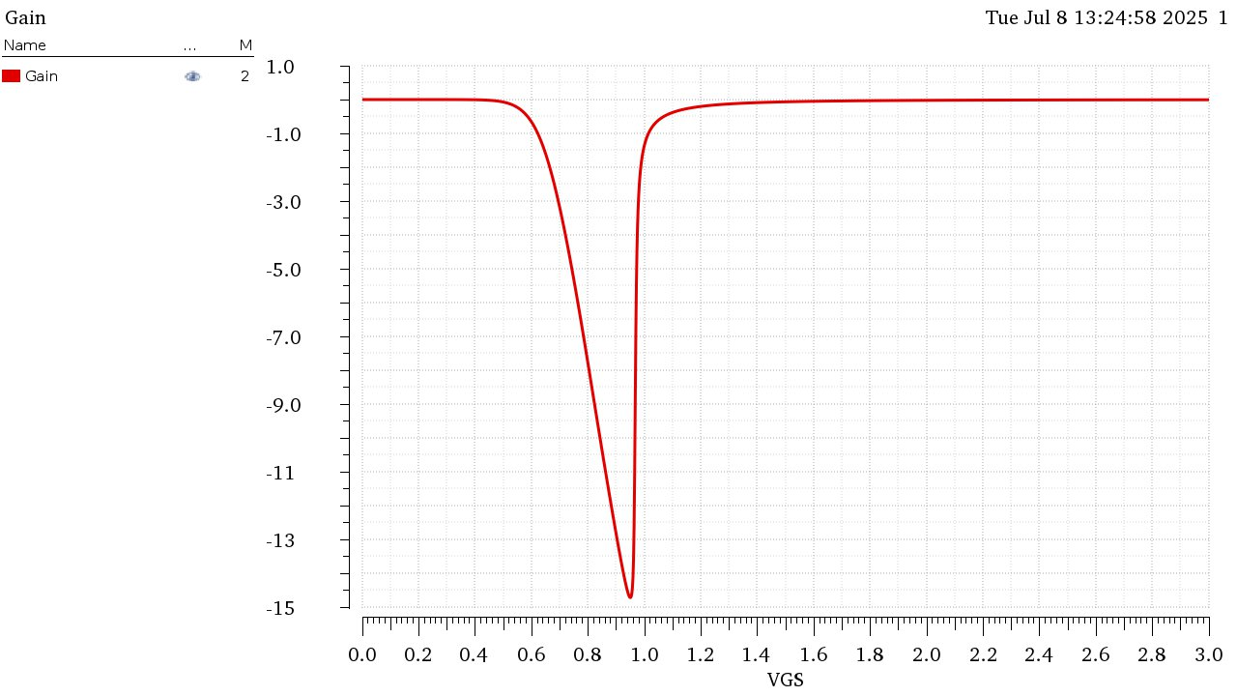

Figure 12 Derivative of VOUT vs VIN graph

Is the Gain Linear?

Since VIN = VGS, gm = 2*ID/Vov = k*Vov depends on VGS and the gain Av = gm*Rd (Depends on gm)

The Gain is the function of the input and as seen from the graph it is not linear. Though if zoomed in for a small signal it can be approximated to be linear in that case.

Transient Analysis:

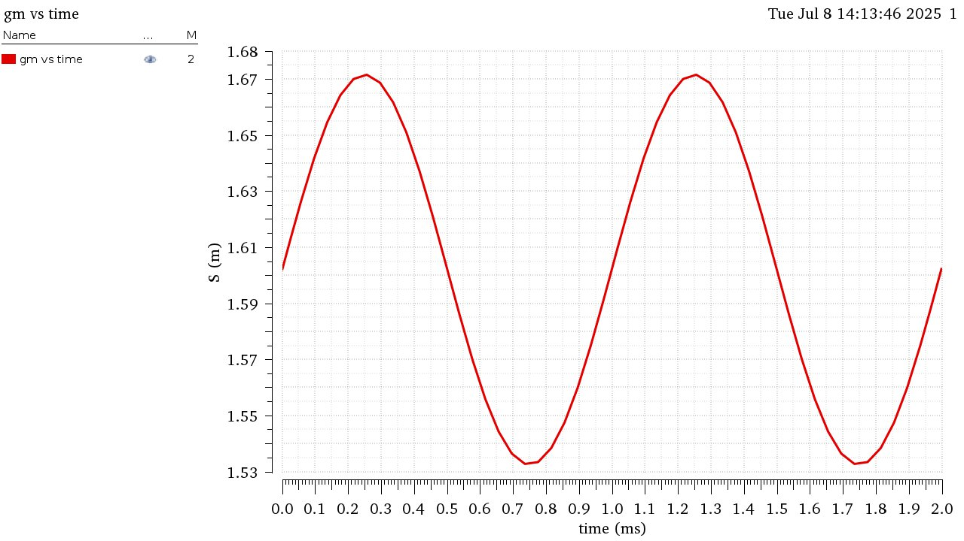

Figure 13 gm vs TIme (Transient Analysis)

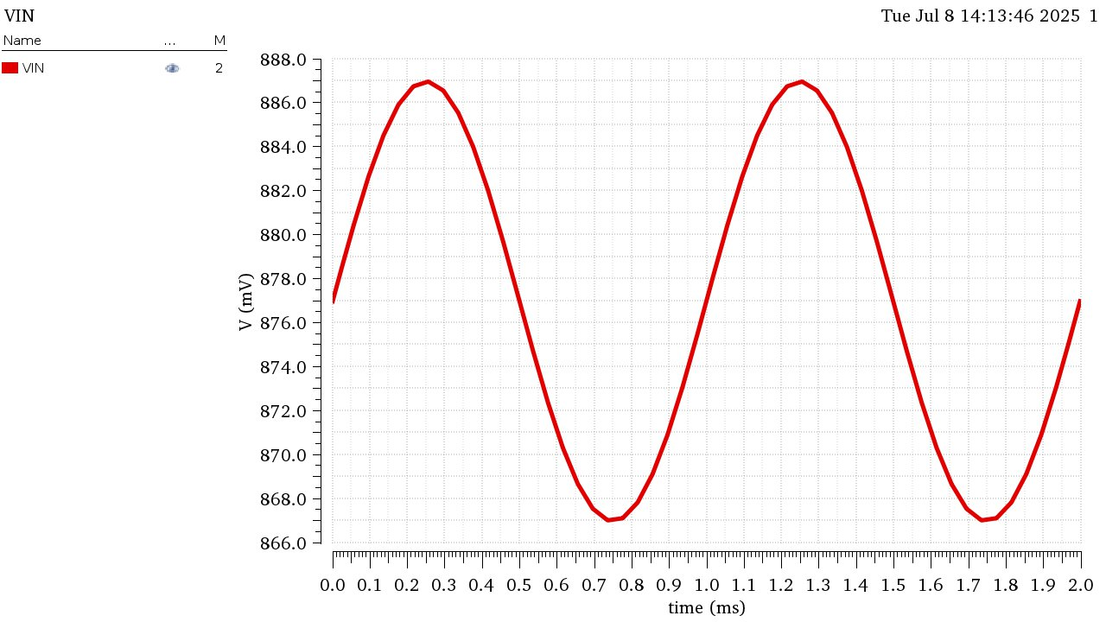

Figure 14 VIN vs Time (Transient Analysis)

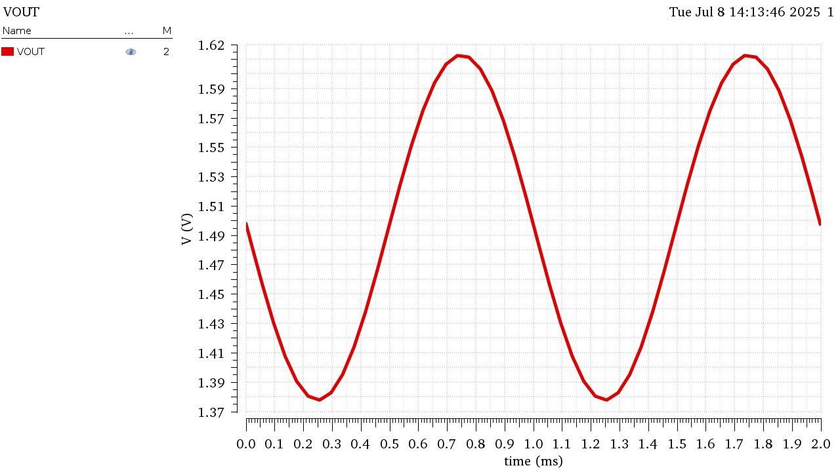

Figure 15 VOUT vs Time (Transient Analysis)

* Does gm vary with the input signal? What does that mean?

gm does vary across time as it is a function of the input. Which means the gain also varies with the input signal

* Is this amplifier linear? Comment.

No , The amplifier is not Linear.

While some linear behavior can be noticed on very small signals, those are merely approximations and do not show the entire picture. Vout varies with Vin which affects different parameters and makes the gain non-linear as well.